**SENG2050 Web Engineering - Assignment 3**

**Development Plan**

**Task Allocation**

We have discussed our group strengths and assigned tasks accordingly.

* Brice Purton will primarily work on the View
* Jonathan Williams will primarily work on the Database and Data Access Model
* Wajdi Younes will primarily work on the Controller and Model

However, tasks may require multiple input and assistance from other members. As this is a group assignment we’ll be sharing a lot of the workload and tasks to make sure our web application integrates seamlessly.

**Integration Plan**

We will be using Git version control with a private GitHub repository from easily collaboration on our project. Development will be done in an MVC design pattern allowing each member to work separately on different concerns without preventing progress in other areas. Tasks will be broken down into logical groupings and worked on sequentially by each group member where the concern matches their primary task allocation. Once each task group is completed it will be integrated into the application then work on the next task group will commence.

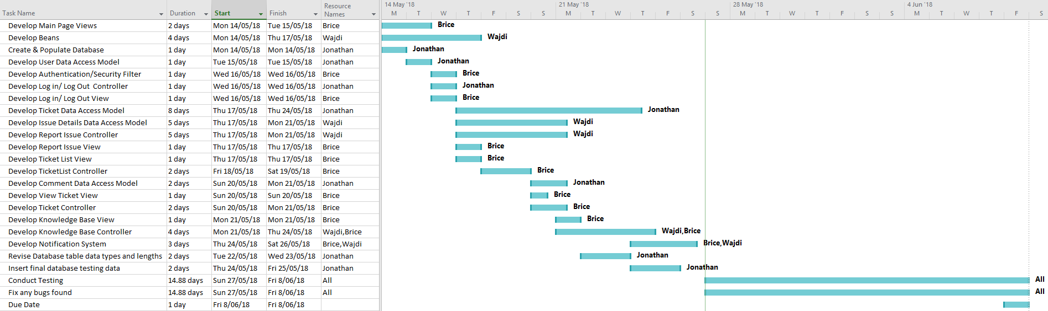**Time Line**